SCENARIO 1

SCENARIO 2

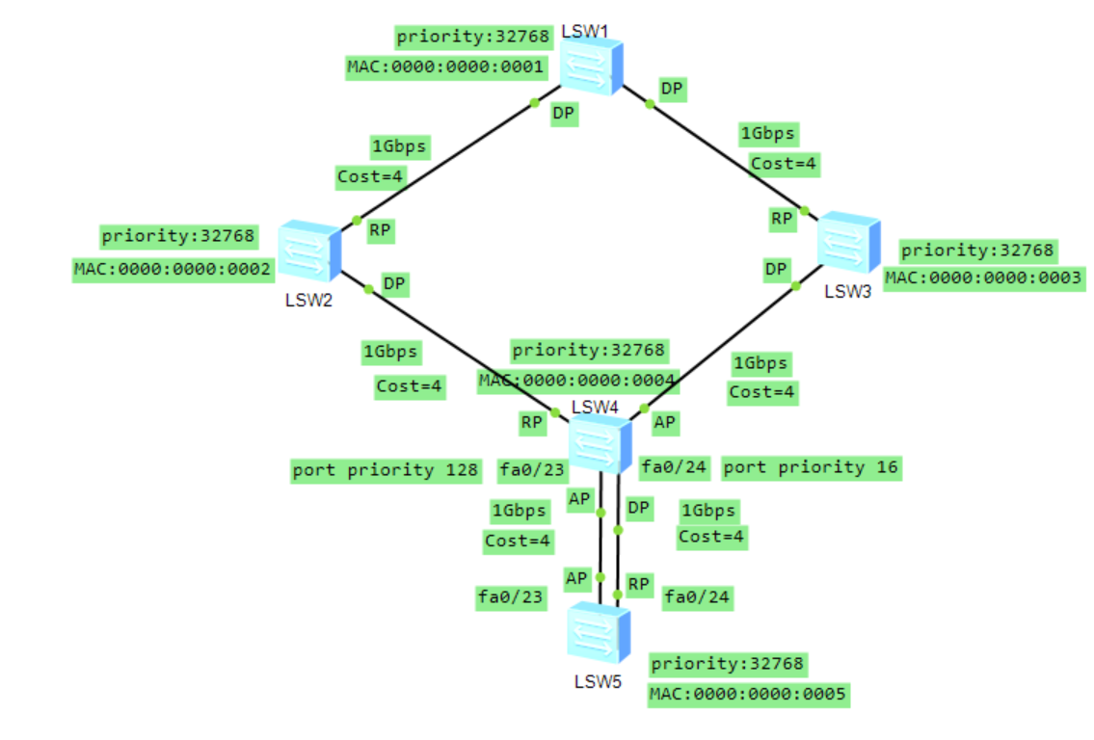

SCENARIO 3

